# Data Flow Diagrams:

**Project Design Phase-II**

# Data Flow Diagram & User Stories

|  |  |
| --- | --- |
| Date | 13 October 2022 |
| Team ID | PNT2022TMID40107 |
| Project Name | Crude Oil Price Predictions |
| Maximum Marks | 4 Marks |

A Data Flow Diagram (DFD) is a traditional visual representation of the information flows within a system. A neat and clear DFD can depict the right amount of the system requirement graphically. It shows how data enters and leaves the system, what changes the information, and where data is stored.

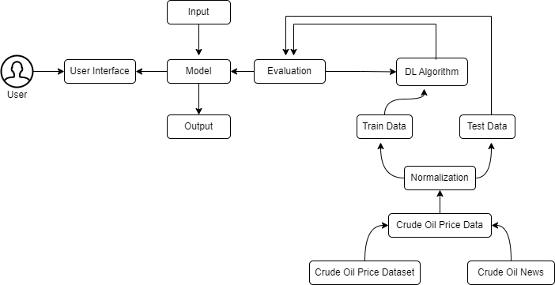

**User Stories**

Use the below template to list all the user stories for the product.

|  |  |  |  |  |  |  |
| --- | --- | --- | --- | --- | --- | --- |
| **User Type** | **Functional Requirement**  **(Epic)** | **User Story Number** | **User Story / Task** | **Acceptance criteria** | **Priority** | **Release** |
| Customer (Mobile user) | Registration | USN-1 | As a user, I can register for the application  by entering my email, password, and confirming my password. | I can access my account  / dashboard | High | Sprint-1 |
|  |  | USN-2 | As a user, I will receive confirmation email once I have registered for the application | I can receive confirmation email &  click confirm | High | Sprint-1 |
|  |  | USN-3 | As a user, I can register for the application through Facebook | I can register & access the dashboard with  Facebook Login | Low | Sprint-2 |
|  |  | USN-4 | As a user, I can register for the application through Gmail | I can register through  already existing mail account. | Medium | Sprint-1 |
|  | Login | USN-5 | As a user, I can log into the application by entering email & password | After registration, I can log in via only email &  password. | High | Sprint-1 |
|  | Dashboard | USN-6 | Display the oil price, line graph / bar graph real time. | I can expect the prediction in various  formats. | Low | Sprint-3 |
| Customer (Web user) | Login | USN-7 | As the user, I can login by using Gmail or Facebook account or LinkedIn or by registering. | Existing users can easily login. | High | Sprint-2 |
| Customer Care Executive | Support | USN-8 | The Customer care service will provide solutions for any FAQ and also provide  Chat-Bot. | I can solve the problems raised. | High | Sprint-3 |

|  |  |  |  |  |  |  |
| --- | --- | --- | --- | --- | --- | --- |
| **User Type** | **Functional**  **Requirement (Epic)** | **User Story Number** | **User Story / Task** | **Acceptance criteria** | **Priority** | **Release** |
| Administrator | Access Control | USN-9 | Admin can control the access of users. | Access permission for Users. | High | Sprint-4 |
|  | Database | USN-10 | Admin can store the details of users. | Stores User details. | Medium | Sprint-4 |
|  | News | USN-11 | Admin will give the recent news of Oil  Prices. | Provide the recent oil  prices. | Medium | Sprint-4 |
|  | Notification | USN-12 | Admin will notify when the oil prices changes. | Notification by Gmail. | High | Sprint-4 |